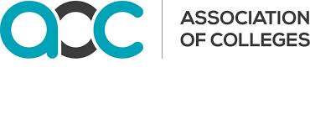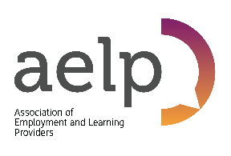
Rt Hon Gavin Williamson MP
Secretary of State for Education
Department for Education
Sanctuary Buildings
20 Great Smith Street
London SW1P 3BT

06 July 2020

Dear Secretary of State,
Impact on Adult Learners of Not Opening for Socially Distanced Face to Face Learning
Adult Education Services/Centres, Independent Providers and Colleges have moved to online provision in a remarkable way. However, they are keen to open their buildings now in a safe way because they want to serve their communities and employers, and start to reskill individuals to support the economic recovery plans.
Providers had drafted their safety-first opening plans, developed their risk registers, ordered their signage and PPE and were ready to start to bring back those adult students who were struggling with the digital offer or needed to complete assessments. Providers are keen to support the recovery programme and were encouraged by the Prime Minister’s comments this week about an enhanced infrastructure plan, which is now at risk, How can that plan be implemented if colleges and providers cannot train the staff needed to work on it?
Providers have shown in the last few weeks that they can successfully open to young students and are fully aware of the risks. So they are prepared to open to adults in a safe and controlled manner.
They are also under pressure to open from other organisations, for example, awarding bodies for assessments, DWP and Jobcentre Plus on working with the unemployed to help them back into work and from Social Services on providing for the socially isolated. Adult students themselves are also keen to return as they are worried about their job prospects and there are only certain types of leaning that can be done online.
Providers are struggling with the Covid-19 policy inconsistencies and cannot see why their training/ education offer is seen to be less safe than others, for example:
- Teenagers can return to school but 19-25s cannot do a retraining course.
- Adults can play sport but not do a coaching qualification.
- Libraries can offer support to the public but not have their adult education centres open to support socially distant CV writing and employability courses.
- Pubs can have groups of six and up to 30 inside with the appropriate social distancing protections in place but adult education providers cannot run a construction class of six with appropriate social distancing protection in place.
- Shopping (non-essential) is allowed, but people are not allowed to take action to improve their life chances - again those furthest away will get left further behind.
We would ask that you reconsider your position and allow safe opening for adult education and skills immediately.
Copies of this letter are being shared with the media.
Yours sincerely,

David Hughes Mark Dawe Susan Pember CBE
Association of Colleges AELP HOLEX

